In this homework lab you will begin by using redirection to manipulate standard input and output.
Then you will write scripts that utilize variables and decision constructs to display and interpret the input and output provided. You will make the scripts executable by assigning them specific access rights, then you will test their performance.
Log in to the VM machine and start working.
<>
Part 1
Type ls command and observe the result. Use the output redirect > to redirect the output of the ls command into a new file called newfile. View the contents of newfile using the cat command. Two > symbols will append the standard output to an existing file. Entering ls –l >> newfile will add a “log” list to the existing newfile. View the contents of newfile using the cat command again.
Type ls enter. And observ the result
Type ls > newfile to redirect the output of the ls command to new file
The output is no longer shown on the screen because we redirected the output.
Type cat newfile and you can see the directory listing
Type Ls –l >> newfile
Now we can append the directory listing this will add a long list to the file
Now we can type $ cat newfile You can see a new list has been added to a new file.
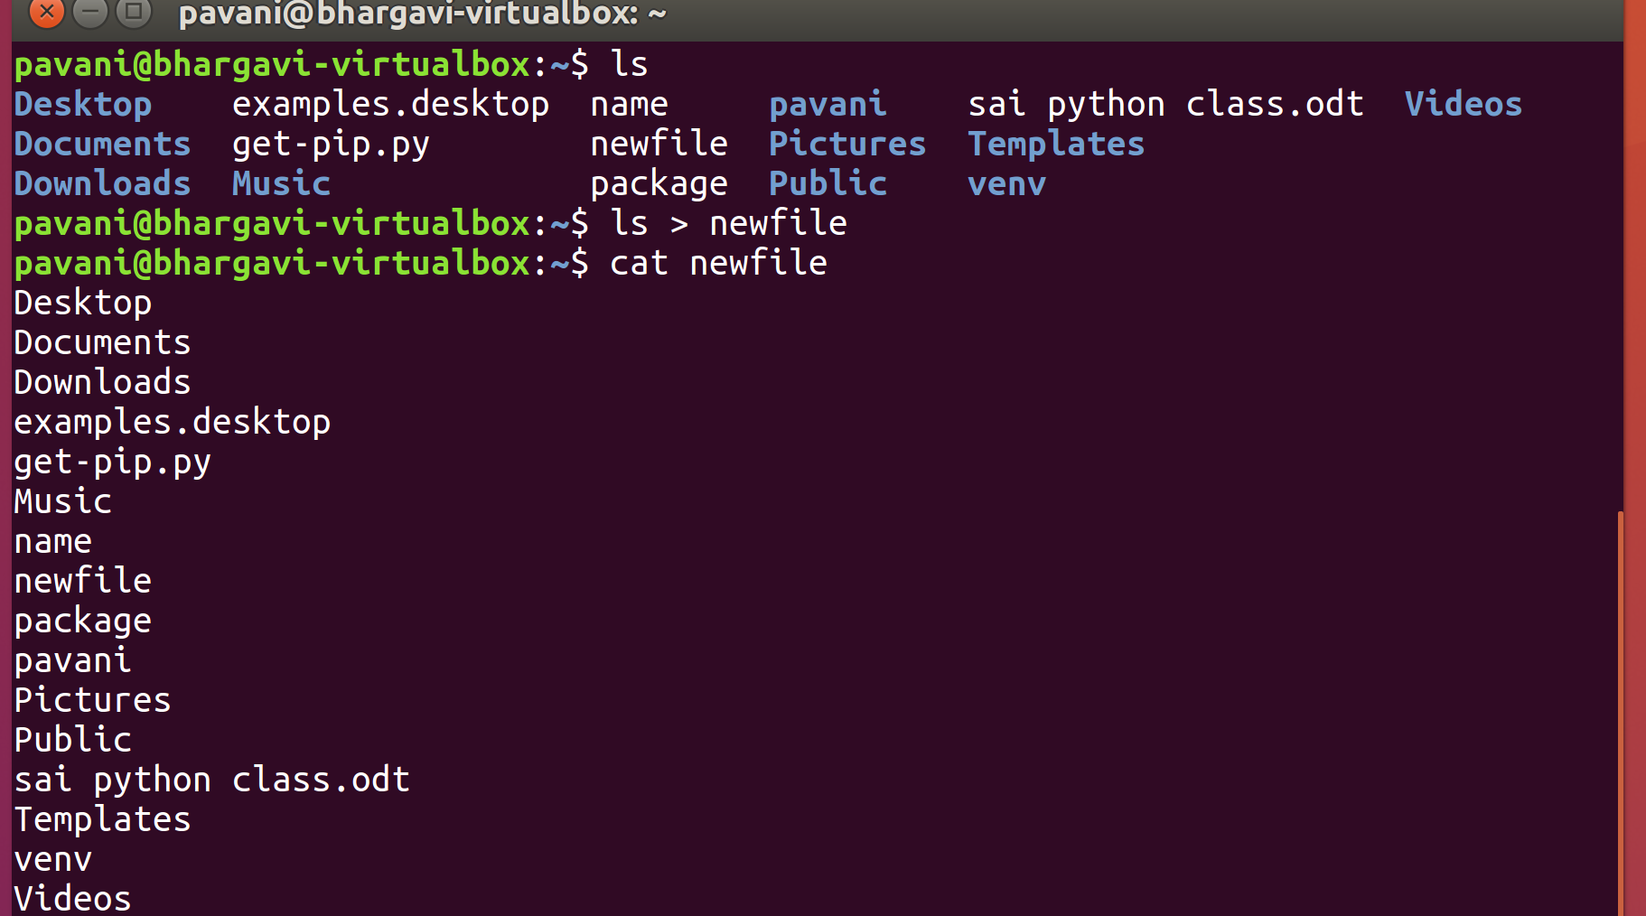
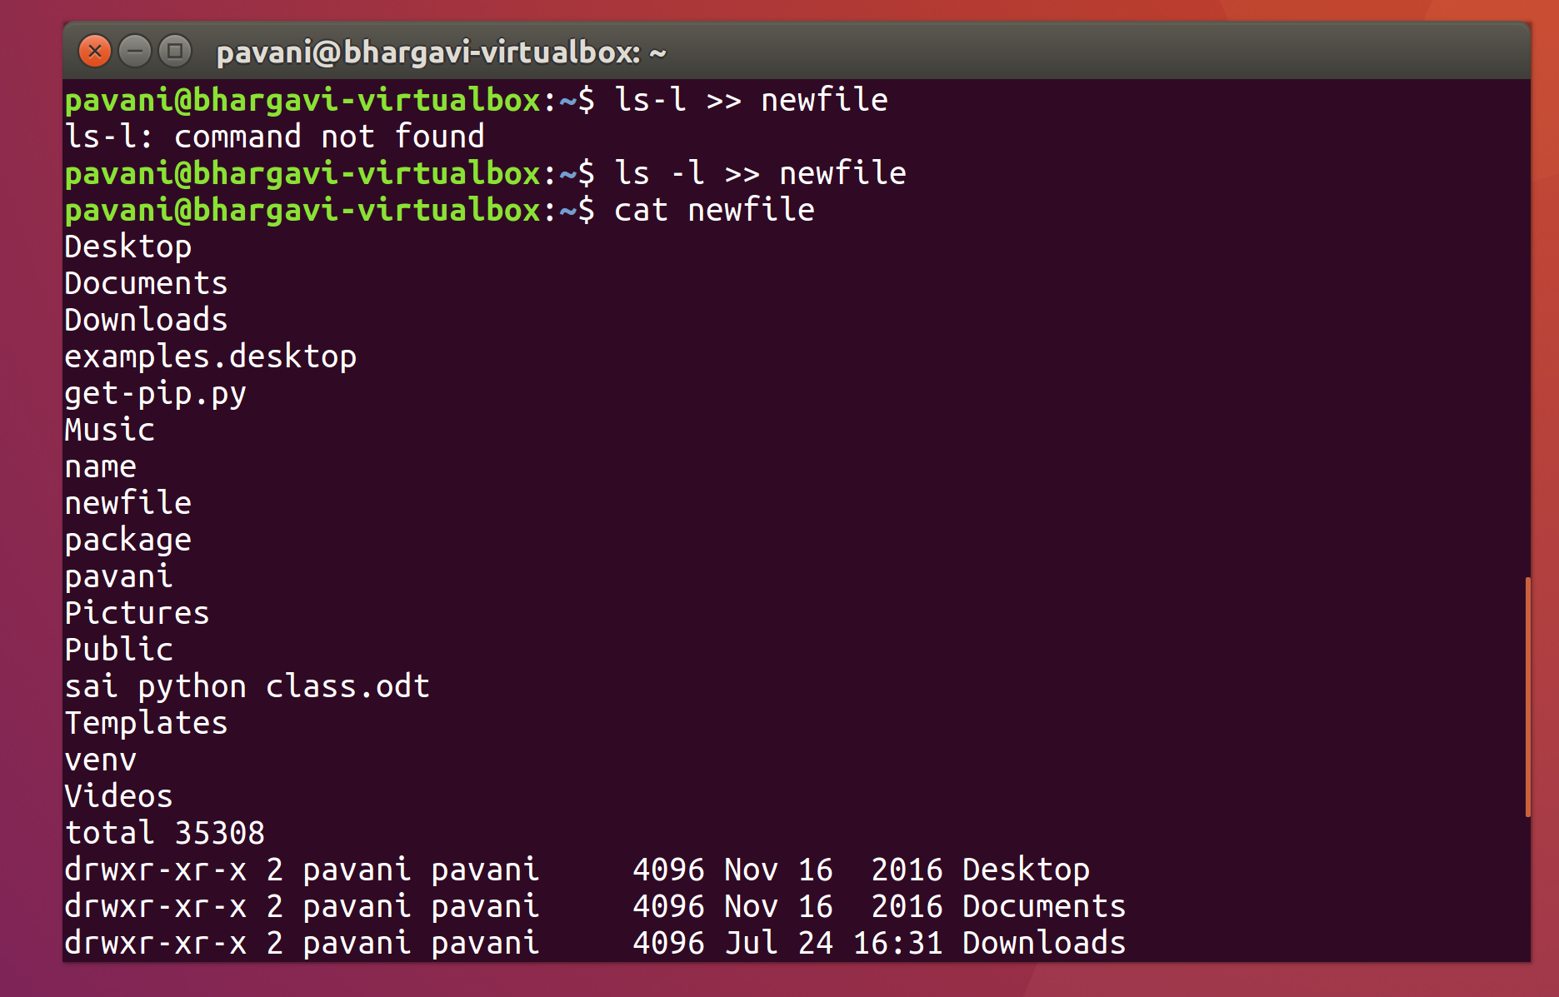
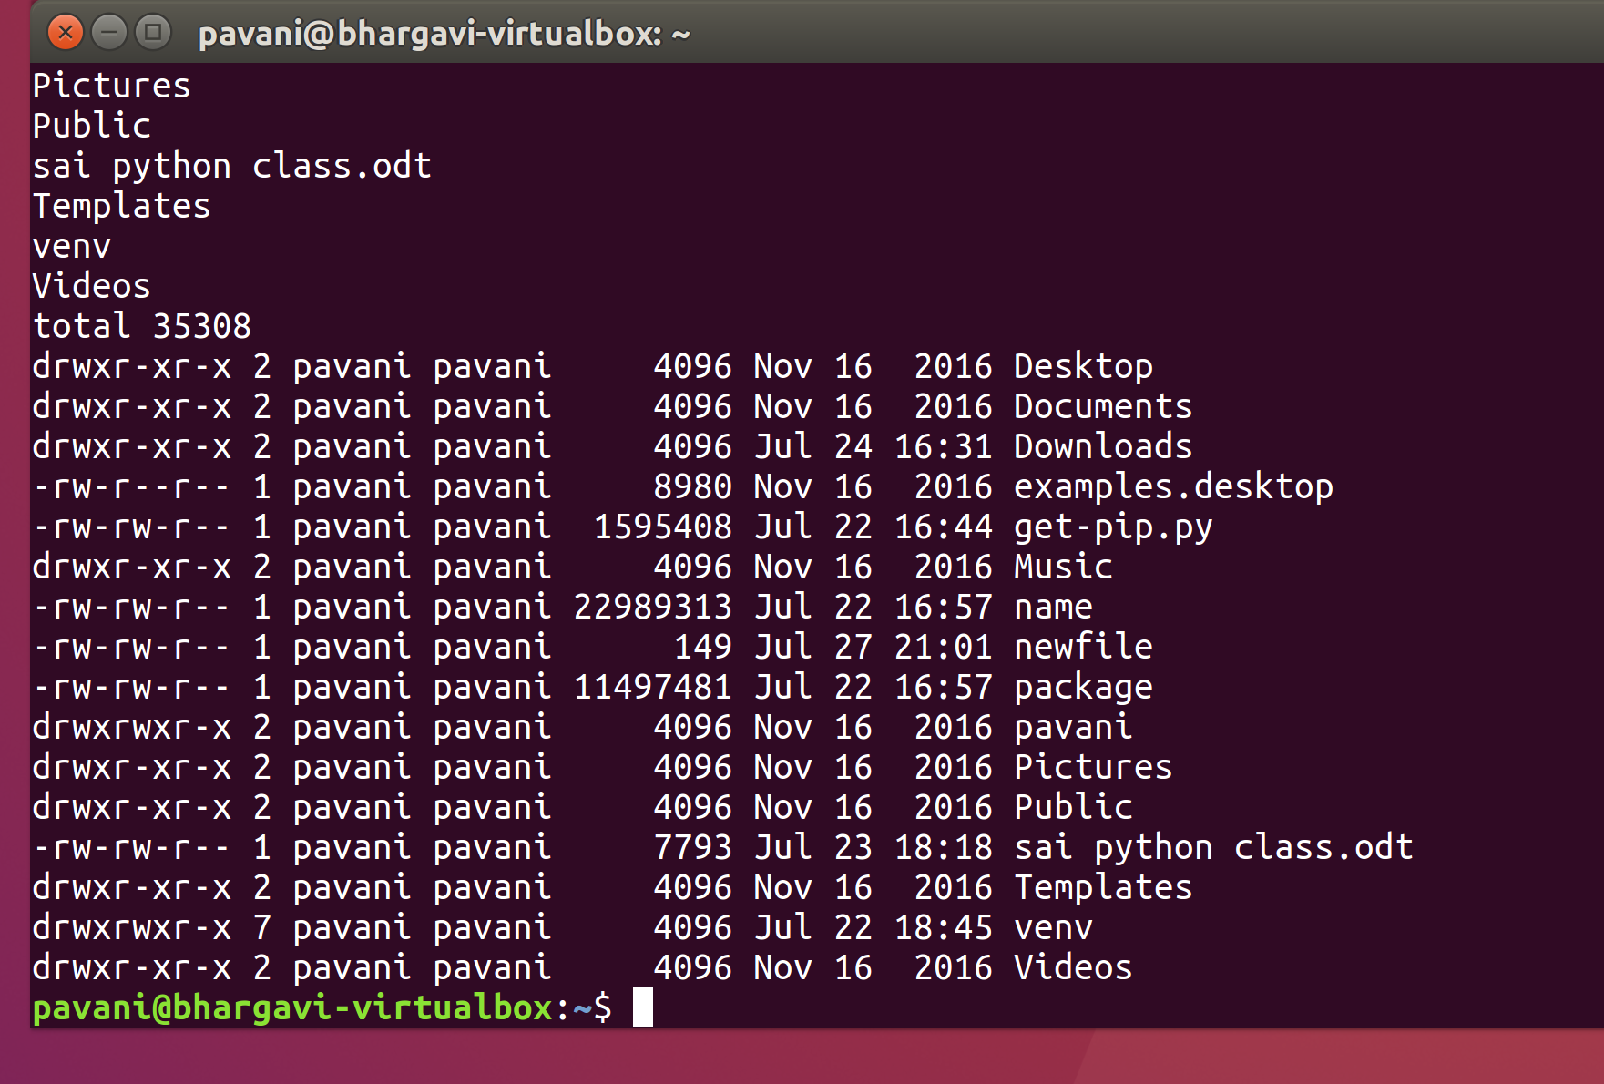
I have entered ls and I got some result like documents, videos, pictures etc..,
I used ls > newfile to redirect the output of the ls command to new file
I used cat newfile and I can see the directory listing
I used Ls –l >> newfile command then we can append the directory listing this will add a long list to the file .
I used $ cat newfile command then we can see a new list has been added to a new file.

Part2
The input redirect < symbol will redirect standard input. For example the tac command (cat backwards) will take standard input and reverse the order. We take the file newfile and use it for input into the tac command by entering tac < newfile. Evaluate the result.
The input redirect arrow will redirect the input. For example
We Type tac < newfile Here we see the directory listing is reversed from that the cat command.
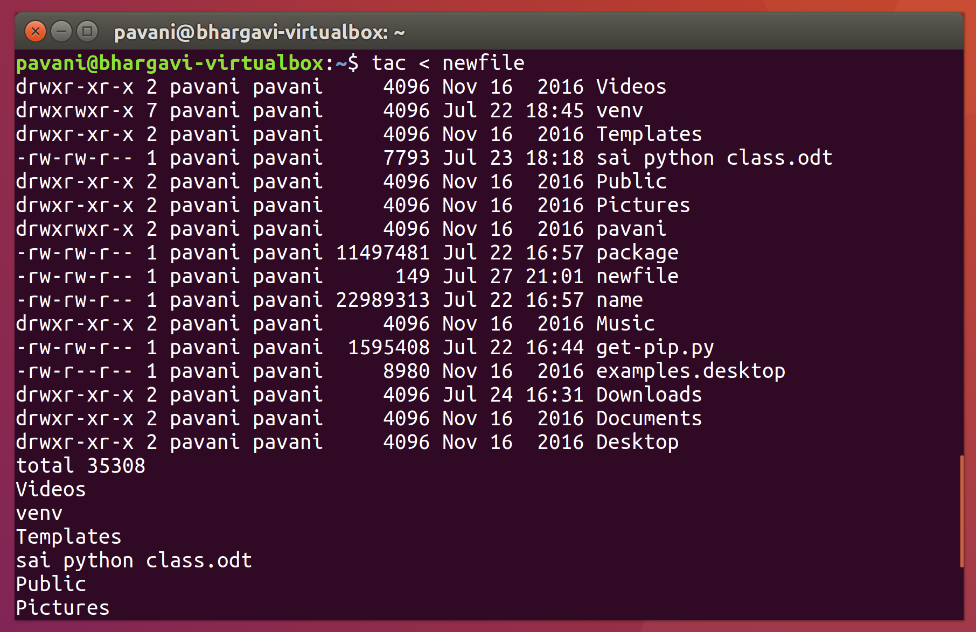
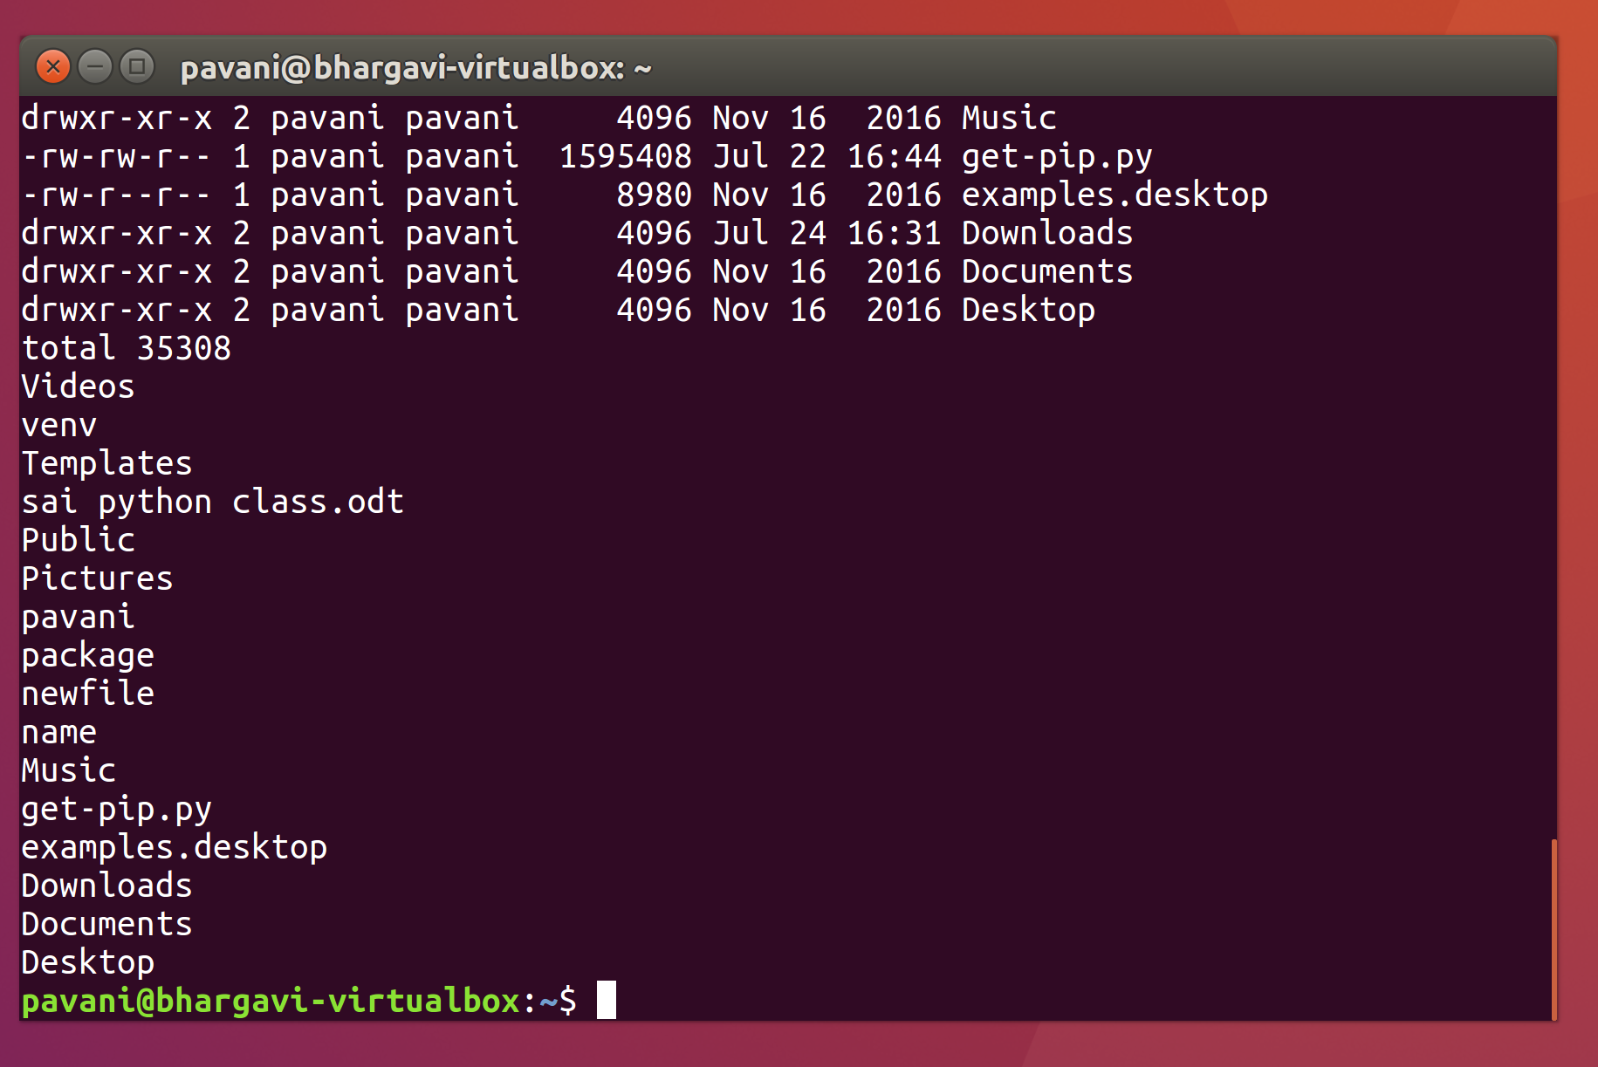
I used tac < newfile command Here we see the directory listing is reversed from that the cat command.

Part 3
We can use input and output redirect symbols <> to redirect the input and output. Enter the command
tac < newfile > elifym. This will take the input from newfile use it for the tac command and redirect the output into another file called elifym. Use the cat command to view elifym. Clear the screen when you are finished.
Type tac < newfile > elifym
Use the cat command to view elifym
Type cat elifym
Clear the scree. $ clear.
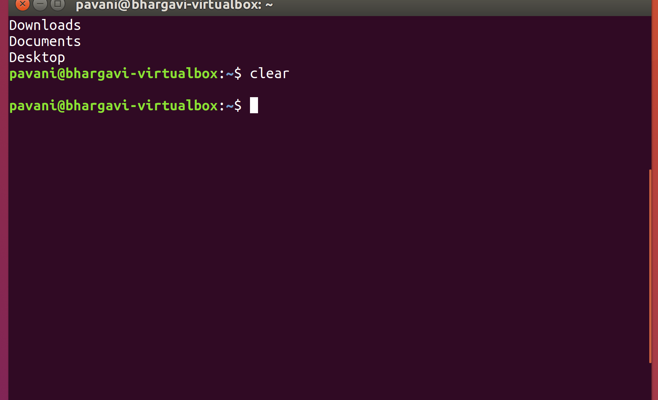
We can use input and output redirect symbols <> to redirect the input and output.
I used tac < newfile > elifym command to take the input from newfile use it for the tac command and redirect the output into another file called elifym. Then I used the cat command to view elifym. Then I used clear command to clear screen.

Part 4
Disply a long list of the /etc directory by entering ls –l. Notice that the listing scrolls by too fast to read it all. Take the output from the ls –l command and redirect it into a command called more using the | pipe. Enter ls –l /etc|more. The pipe will work with or without spaces. Notice the screen pauses and waits for you to press enter ( or spacebar) to view the complete output page by page. Clear the screen when you are finished.
We can Take the output from the ls –l command and view it on one page.
Type ls –l
And redirect it to other command and pus it each page.
Type ls –l /etc|more here we see it stops at one page we can move by hitting enter or spacebar.
$ Clear>.
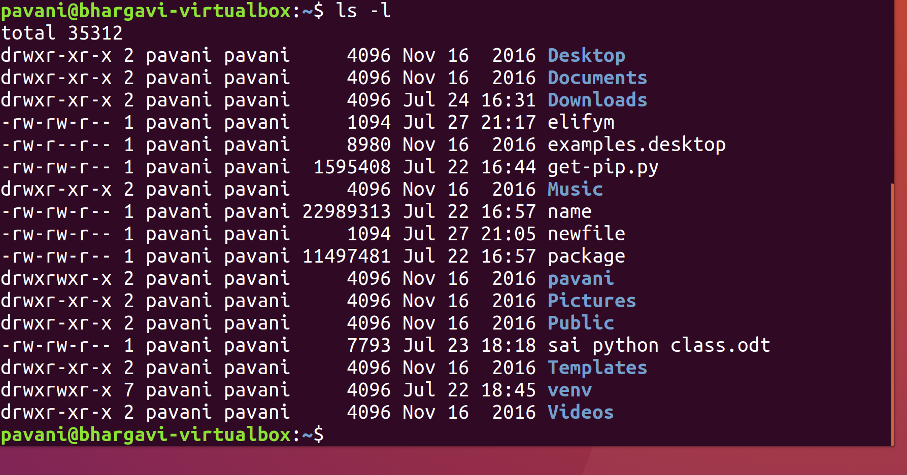
We can Take the output from the ls –l command and view it on one page.
I used ls –l command to redirect it to other command and pus it each page.
I used ls –l /etc|more command to see it stops at one page we can move by hitting enter or spacebar.
$ Clear> command to clear screen.

Part 5
Use the grep command to search and disply lines from our newfile that contain the word documents. Use the –i switch to search for both upper and lower case. Type cat newfile | grep –i documents. Next redirect the output into a file called docs using the >. View the docs file using the cat command. Clear the screen when you are finished.
Type cat newfile | grep –i documents when executed it we can see all the files that are in the documents.

Type cat newfile | grep –i documents > docs Now we can look in that file by Typing
$ cat docs we can see that it contain the information. And we clear the screen.

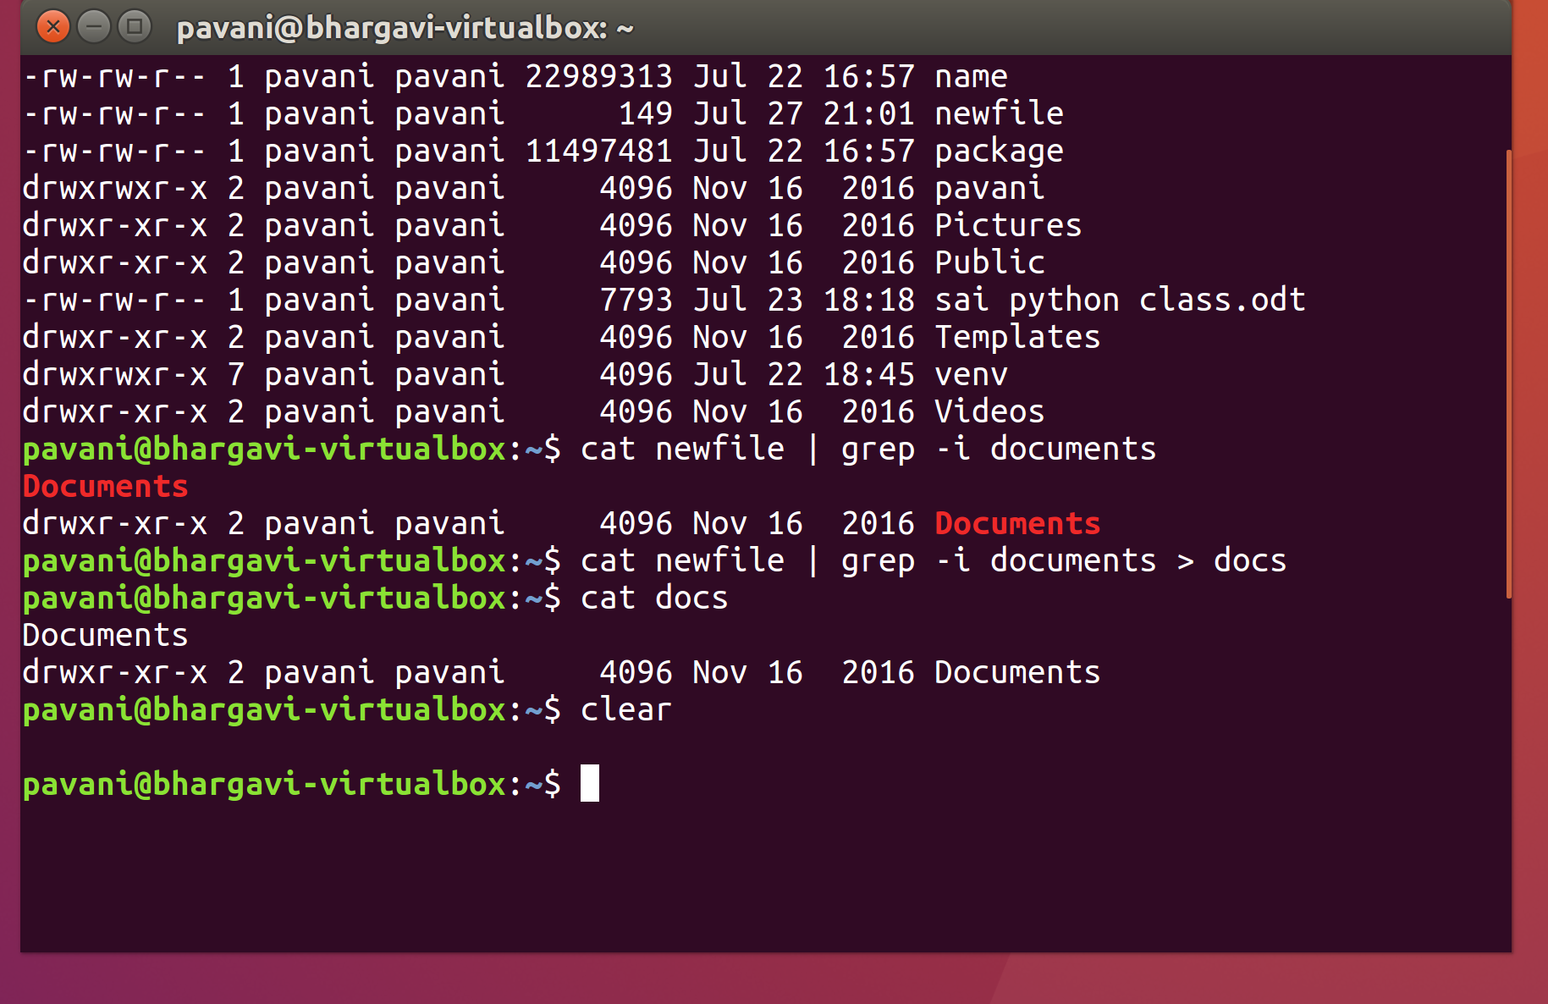
I Used the grep command to search and disply lines from our newfile that contain the word documents. I Used the –i switch to search for both upper and lower case.
redirected the output into a file called docs using the >. We can see the docs file using the cat command. Clear the screen using clear command
used cat newfile | grep –i documents command when executed it we can see all the files that are in the documents.
Used $ cat docs command then we can see that all the information.
Clear command used to clear screen.

Part 6
Shell scripts allow you to take multiple commands and run them in order. You will create a script that will output hello using the following command: cat > myscript - #! /bin.bash – echo “Hello” -
Type $ cat > myscript create the file if its exist or empty it if its exist.
Now we can begin to create the script
#! /bin/bash We using the bash shell the second script is the echo command which is just echo what is written after it.
Type $ echo “Hello”
Control C saves the file.
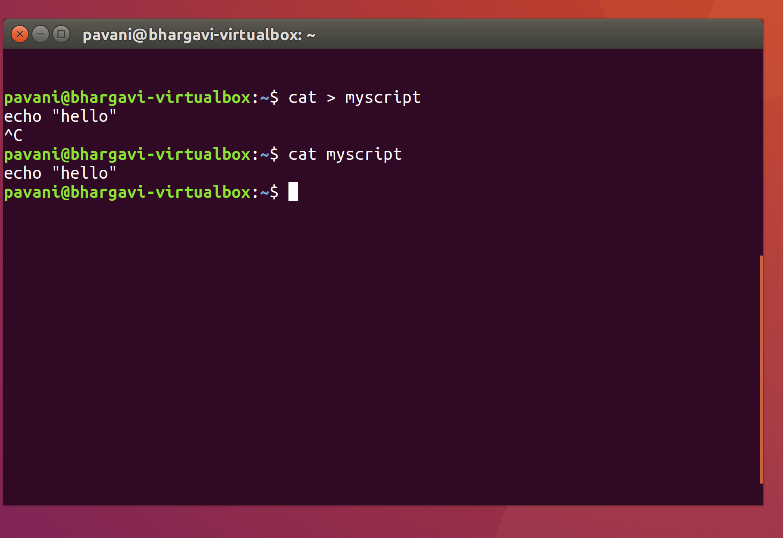
used $ cat > myscript used to create the file if its exist or empty it if its exist.
Used #! /bin/bash command to the bash shell the second script is the echo command which is just echo what is written after it.

Part 7
Now that the script is created , we must make it an executable file by using the chmod command. The value 764 will make it executable for the owner. Type chmod 764 myscript and press enter. Now to run the command type ./myscript. Here we will use the $USER variable to echo our username. Use the vi editor to edit our file. Type vi myscript. Type letter i to enter insert mode. Place the insertion point at the end of Hello and add a space and the shell variable “Hello $ USER”. Press the ESC key and type :wq and press Enter to write and quit. Run the command again and note the change. Clear the screen.
Type chmod 764 myscript 764 make it executable for the owner.
We test it by using
$ ./myscript This make Linux look in the current directory of my script. Here we can see return the result hello.
Now we edit the file by Typing
$ vi myscript
Type the letter i to enter the insert mode.
No we can arrow the end of the line Hello and add shell variable echo”Hello $USER”
We exit by ESC colen :wq.
The file is already executable so we can test it by Typing
$ vi myscript and again type.
$ ./myscript This time it returns Hello plus the current user name.
$ clear.

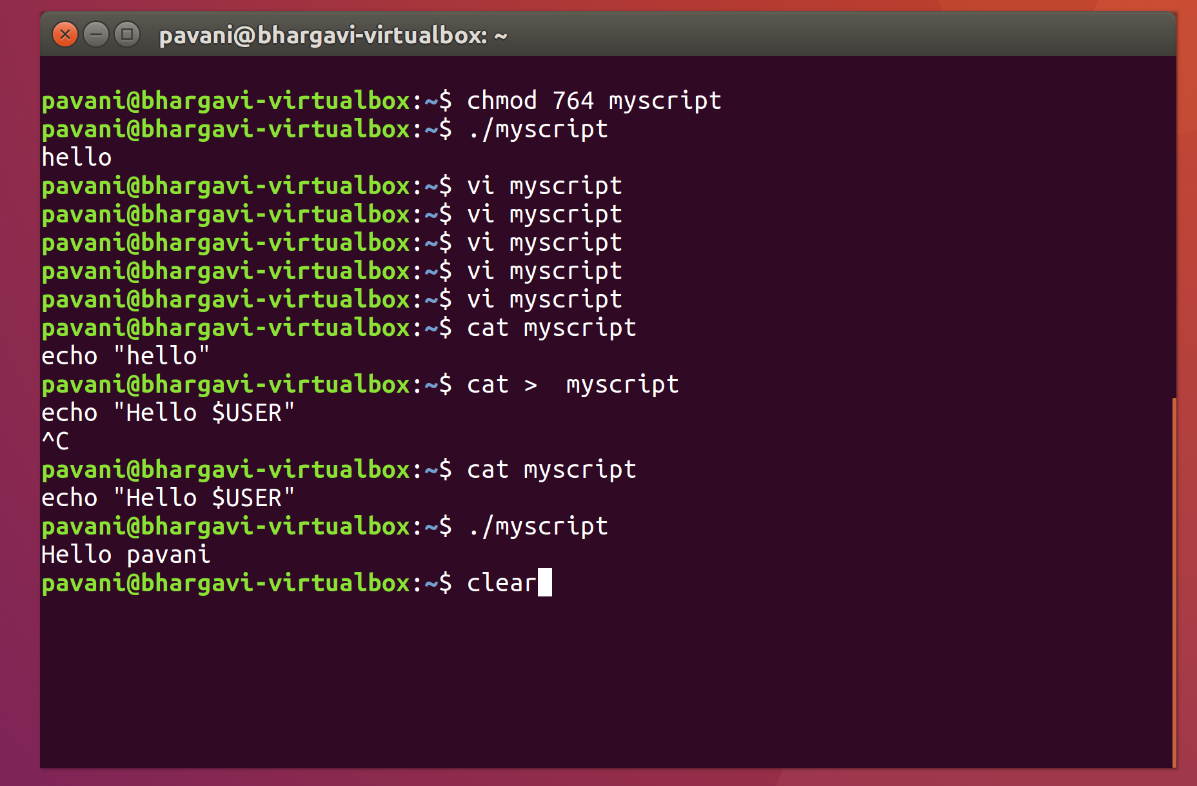

Type chmod 764 myscript in this command 764 make it executable for the owner.
We test it by using
$ ./myscript This command make Linux look in the current directory of my script. Here we can see return the result hello.
We can edit using this command $ vi myscript
I have used I letter to enter the insert mode.
I have added shell variable echo”Hello $USER”
$ ./myscript This time it returns Hello plus the current user name.
$ clear Command used to clear the screen.

